Supplementary Information

Supplementary Research Support Information:

ARIC: A collaborative study supported by the National Heart, Lung and Blood Institute contracts N01-HC-55015, N01-HC-55016, N01-HC-55018, N01-HC-55019, N01-HC-55020, N01-HC-55021, N01-HC-55022 and R01HL087641; National Human Genome Research Institute award U01HG004402; NIH Intramural Research award ZIAEY000426 from the National Eye Institute; and National Institutes of Health contract HHSN268200625226C. Infrastructure was partly supported by Grant Number UL1RR025005, a component of the National Institutes of Health and NIH Roadmap for Medical Research. The authors thank the staff and participants of the ARIC study for their important contributions.
JHS: The Jackson Heart Study is supported by contracts HHSN268201300046C, HHSN268201300047C, HHSN268201300048C, HHSN268201300049C, HHSN268201300050C from the National Heart, Lung, and Blood Institute and the National Institute on Minority Health and Health Disparities.
MESA: MESA and the MESA SHARe project are conducted and supported by the National Heart, Lung, and Blood Institute (NHLBI) in collaboration with MESA investigators. Support for MESA is provided by contracts N01-HC-95159, N01-HC-95160, N01-HC-95161, N01-HC-95162, N01-HC-95163, N01-HC-95164, N01-HC-95165, N01-HC-95166, N01-HC-95167, N01-HC-95168, N01-HC-95169, UL1-TR-001079, and UL1-TR-000040. The MESA CARe genotyping data used for the analyses described in this manuscript was funded by NHLBI Contract N01-HC-65226. Additional support was provided by NIH grant HL69979-03 (RK and TY) and the NIH Intramural program award ZIAEY000403 (MFC).

Supplementary Figure S1. Plot of first two principal components of HapMap YRI (Yoruban African) and CEU (European) samples and participants by (A) Case-Control Status and (B) Cohort Study

A.
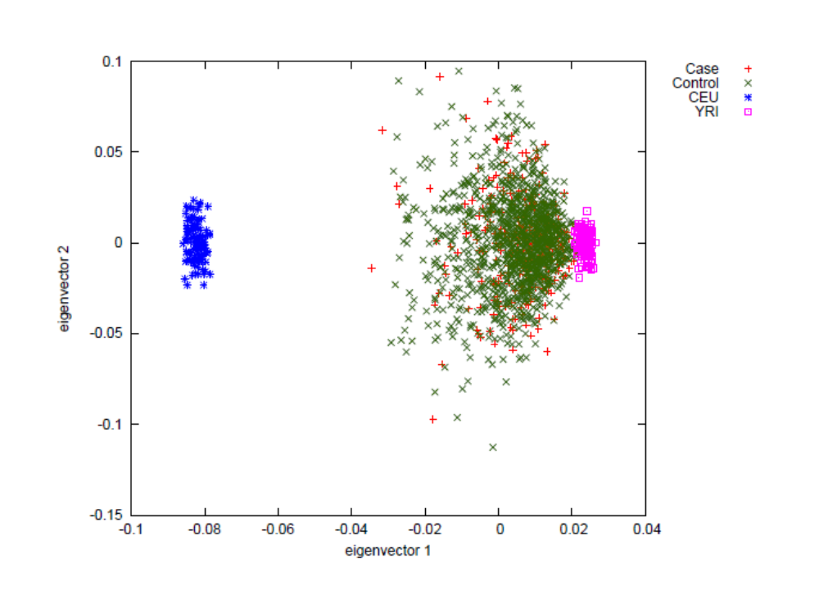

B.
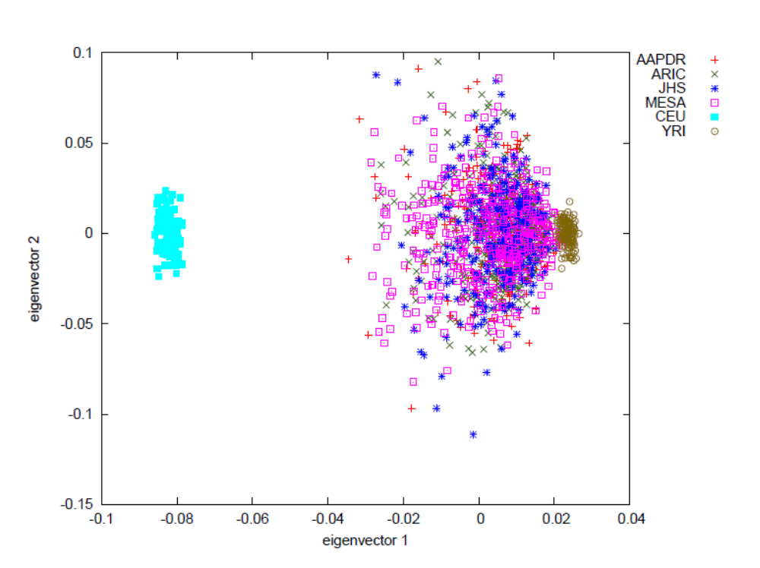

Supplementary Figure S2. Genome-wide admixture mapping scan for loci associated with diabetic retinopathy in the African American Proliferative Diabetic Retinopathy Study where controls all had type 2 diabetes for at least 10 years and no proliferative diabetic retinopathy. The maximum locus genome statistic score was 2.67 on chromosome 14 which did not meet genome-wide statistical significance. The dashed line indicates the level of genome wide significance (locus genome statistic score of 5).

